**Project overview**

**This Equals webapp design and development for TMForum**

**Summary:**

Proposed contracted work between This Equals and TMForum. Agile project management conducted by John Kellas (This Equals) and Paul Wilson (TMForum). A discounted rate £2.5k for design and rapid build work with following outputs.

**Key deliverables**:

1. In advance of the TMForum China presentation (18th September 2017), This Equals will deliver an

**interactive 3D Globe (‘TMglobe+’) html based webapp** - with close parity to the following designs:

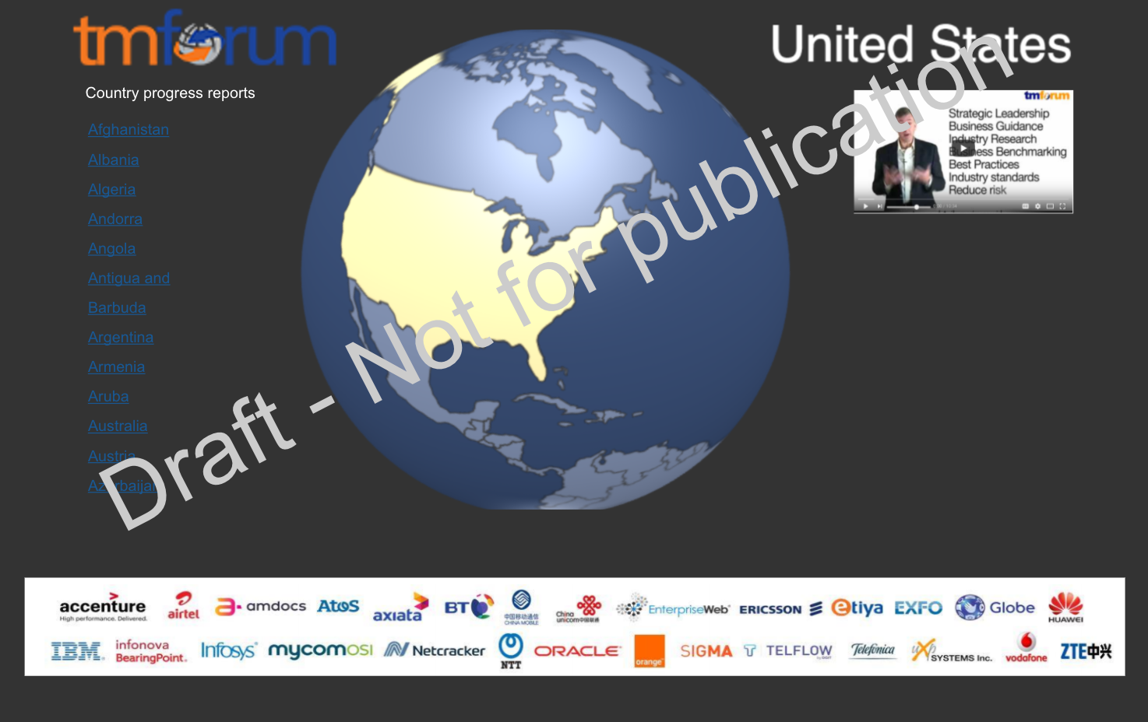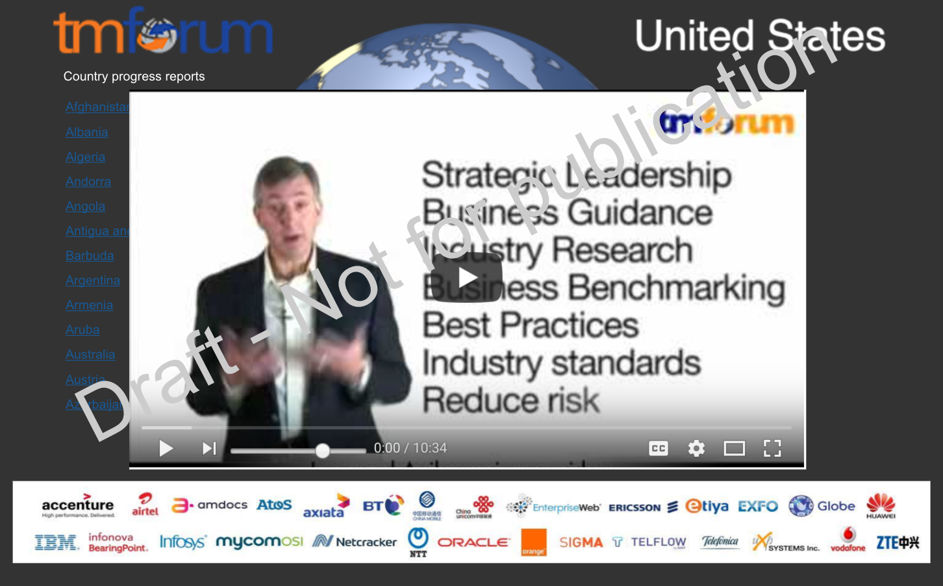

The webapp will feature a rotating globe that shows PDFs and videos from 86 countries/cities; click on a country on the map, or choose from a list of countries to centre the globe - on selection, either a PDF or a video will display. Deliverables to include all required files for local hosting and display via Google Chrome (current version), or hosting on TMForum website.

2. Design and development of a **TMForum visual leitmotif** - to aid understanding to the complexity of

staff time allocation in relation to (27) activity domains and profitability (digitising and developing designs

from the TMForum visual Leitmotif document - Paul Wilson 24th Aug 2017)

|  |  |
| --- | --- |
|  |  |

* Graphics provided for illustrative purposes, diagram on right shows example digital layout that we will create
* Project delivered with mock data - pending review and staff engagement post Board review mid October
* Designs and codebase for webapps shall be granted in perpetuity by This Equals to TMForum on a non-exclusive basis.